# GitHub Entry

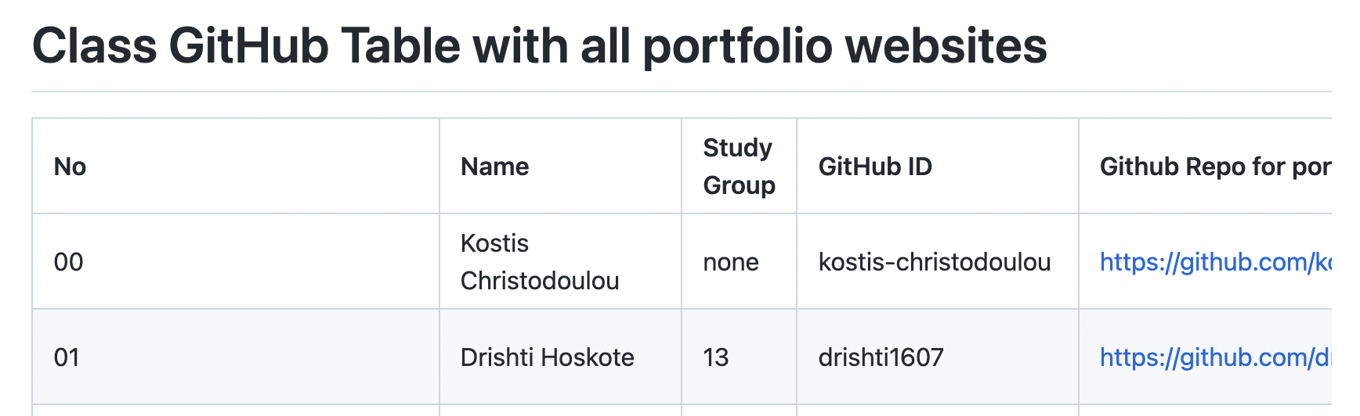

# Webpage Screenshot - <https://drishti-hoskote.netlify.app/>

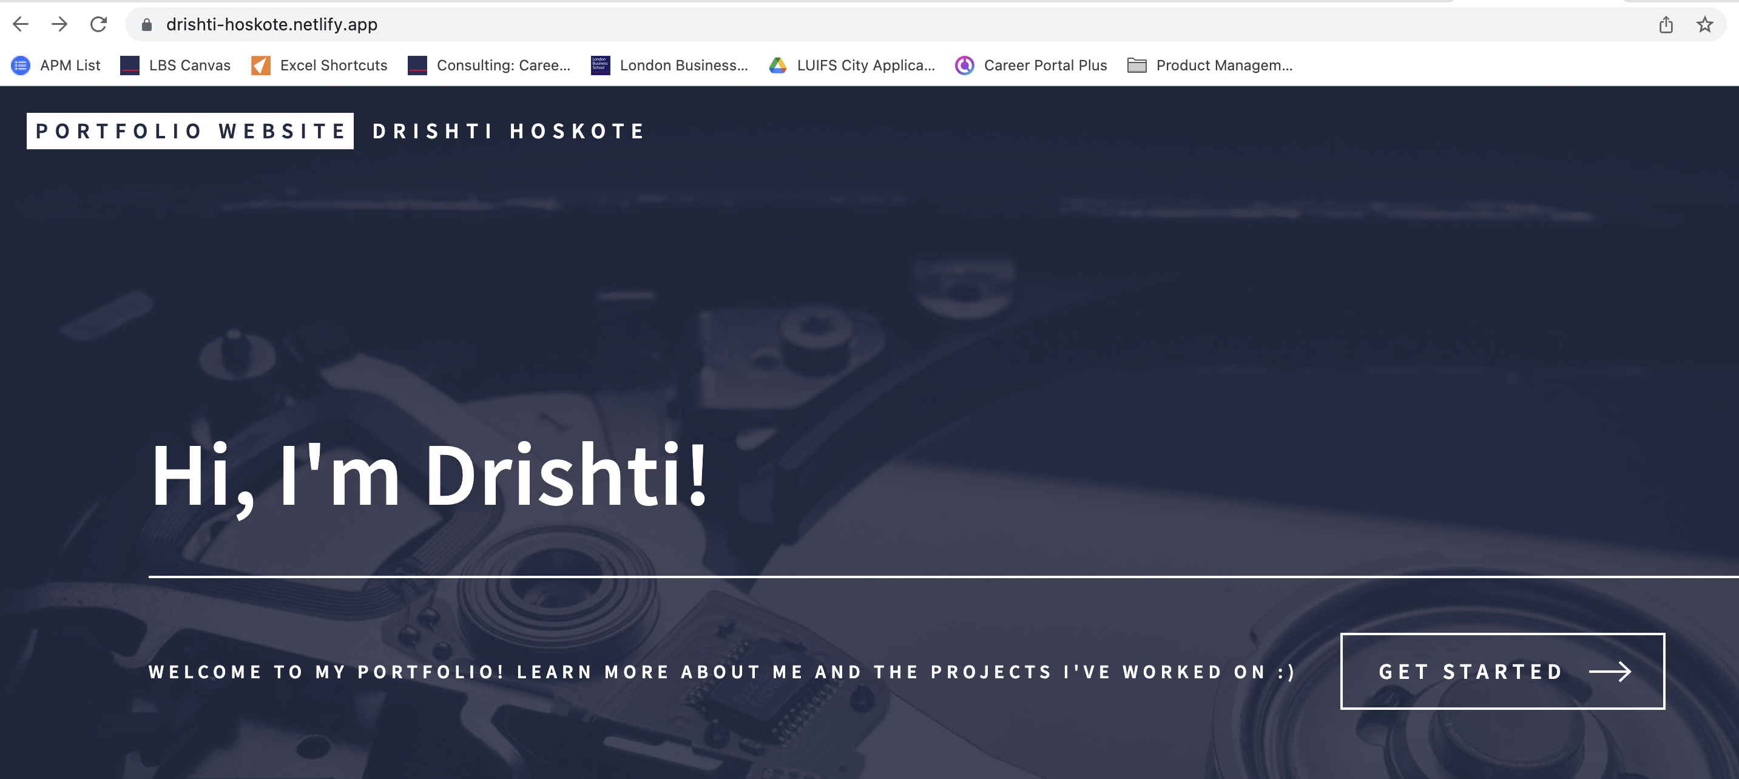

# GitHub Repository - <https://github.com/drishti1607/my_website>

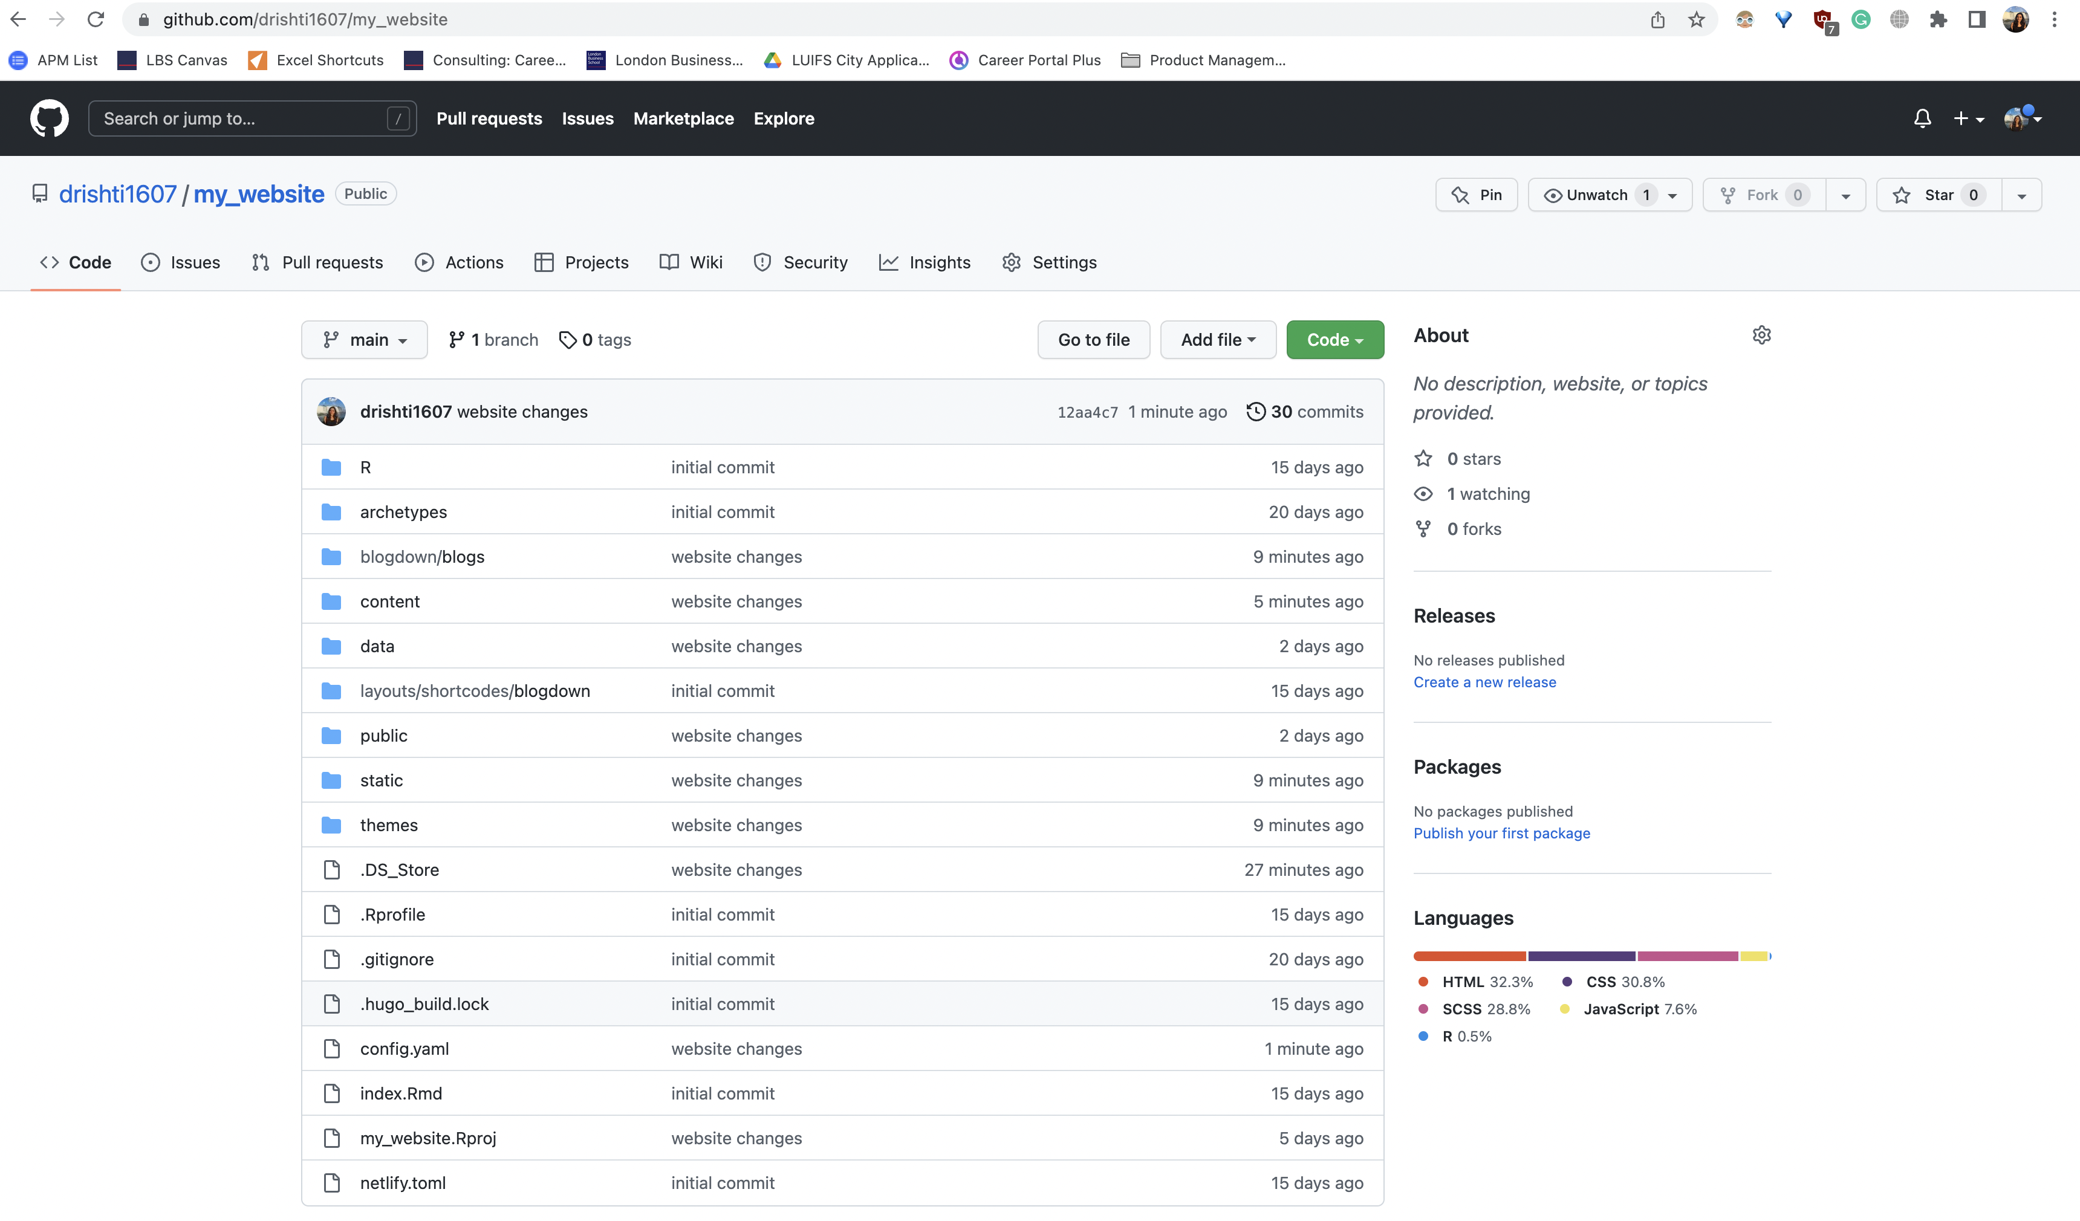

# Netlify Account

